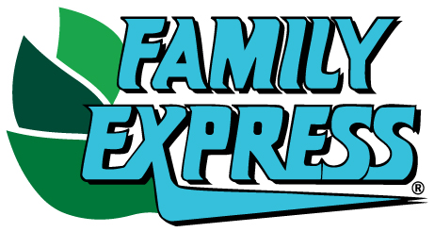

COMMUNITY INVOLVEMENT REQUEST FORM

PLEASE NOTE: ALLOW 2 WEEKS MINIMUM NOTICE FOR DONATION(S) REQUESTED

All donated item(s) will be picked up from the distribution center (or office) in Valparaiso. This can be done Monday thru Friday, 9am to 3pm.

Donor Information (please print or type)
DATE OF YOUR REQUEST | Click or tap to enter a date.
WHAT IS THE NAME OF YOUR ORGANIZATION?

Is this Organization a 501(c)(3) approved entity? Yes No
If Yes, are you able to provide a copy of the current Letter of
Determination, if requested? Yes No
WHAT IS THE EVENT NAME?
WHAT DATE IS THE EVENT? | Click or tap to enter a date.
WHAT IS THE LOCATION OF THE EVENT?
WHAT IS THE ANTCIPATED NUMBER OF ATTENDEES?
WHAT DATE/TIME DO YOU PREFER TO PICK UP DONATION?  (Date & time must be completed) | Click or tap to enter a date. Time: AM PM
WHAT ITEM(S) ARE YOU REQUESTING FOR DONATION?
(Only Family Express branded product is considered for in-kind donations such as water, bakery, milk, gift cards)
INDICATE A CONTACT PERSON  (Please include a Name, Phone No. and Email) | NAME:  PHONE:  EMAIL:

PLEASE COMPLETE: Our gifting objectives include support of patriotism or love of country, and we ask that requesters support this objective with us. Some examples include utilizing the American flag (large or small) in some way at the event or the national anthem or reciting the pledge of allegiance, use of red, white and blue decorations, tablescapes or clothing, or military recognition and support are also good ways to convey this objective.

Click or tap here to enter text.

Please fill out and email mkamaski@familyexpress.com or fax to 219-477-5499 Attn: Marie Kamaski

